**How to Download and Install the postman-**

**Step 1-** Go to <https://www.postman.com/downloads/> and choose your desired platform among Mac, Windows or Linux. Click Download.

**Step-2-** Click on windows 32 bit or 64 bit as per your operating system. So it will take time to download it.

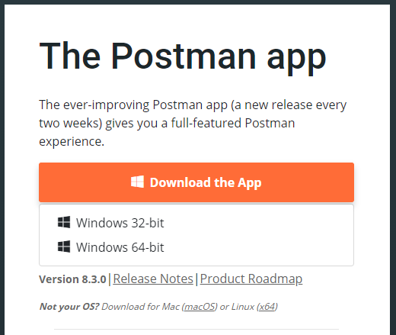

**Step-3- Go to downloaded folder location and double click on exe file.**

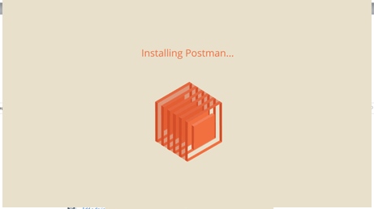

**Step-4 it will displayed the below screen as**

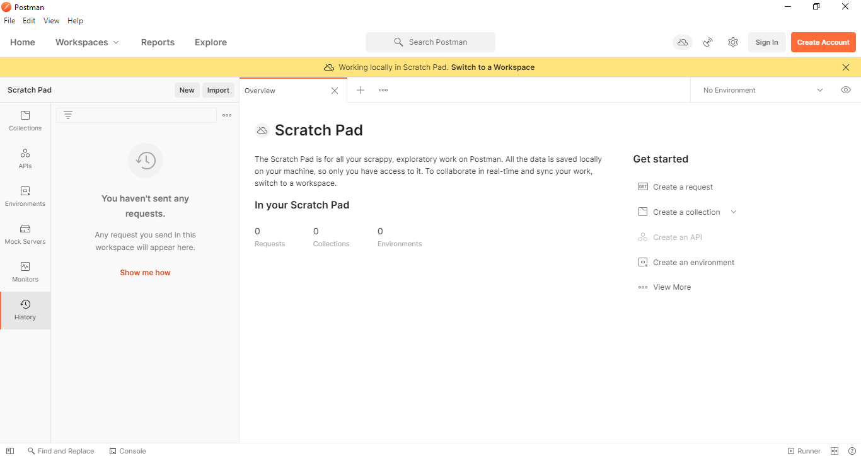

**Step-5- Click on + icon below**



**Step-6- Enter the URL into request URL**

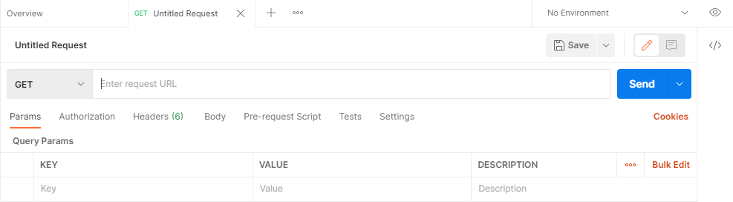

**Step-7**- Hit Send button to get the response